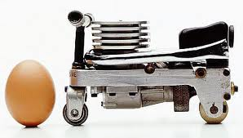

Ever dreamed riding the smallest motorcycle in the world. A designer from Sweden, Tom Wilberg made the smallest motorcycle in the world. How about the size? It is not as big as fist adults. Although it is so small, adult person may ride it. This motorcycle was created in 2003.
How small the motor is! The height is only 6.5 cm and the length is 11.4 cm. The diameter of the front wheel is just 1.6 cm. Meanwhile, the rear wheels is not more than 2.2 cm. The wheelbase is only 8 cm. As a driving power, Tom installed mini machine which has power about 0.3 kw.
At the first time I knew this motorcycle, I was in doubt whether we can ride it or not because of its small size. But, Iʼm wrong. You are able to ride it. If you want to ride it, there are two alternative ways. First, you use a stiff. Second, you can use two feet like squating on the iron appeared there. How about the speed? From the result of trying out, this motor can be taken as far as 10 meters with a speed of 2 km / hour.
Because it can can carry people, the motorcycle designed by Tom Wilberg is respected as the smallest motorcycle in the world by Guiness Books of Records. Untill now, the record of the smallest motorcycle in the world has not been broken. Meanwhile, Tom is still innovating to make the tallest motorcycle in the world.

